Maria Neely

MACS-405 Final Paper

**Twitter Bots and the 2018 Midterm Elections: Analyzing Differences in Tweets between Bots and Humans**

**I. Introduction**

In today’s hyper-political climate, disinformation is a political and economic issue worldwide. Disinformation campaigns, defined as the dissemination information that is known to be false, are commonly generated by automated bots run by government-supported organizations in Russia, China and Iran (“Threat to US elections in 2020”). Disinformation campaigns have been identified in countries such as Tunisia, Mozambique, Cameroon, Sudan , Libya, the Baltic states, Montenegro, Spain, Taiwan and the United Kingdom and the United States, to name a few (“Russia has turned its interfering attentions to Africa”). These campaigns aim to move public opinion by spreading propaganda on a specific topic, such as through the support of a specific candidate or party in an upcoming election, or a piece of legislation. This practice was brought to public attention during the United States’ 2016 presidential election, during which Russia ran a disinformation campaign, through the Kremlin backed Internet Research Agency (IRA) (Masters, “Russia, Trump and 2016 elections”). Campaigns such as the IRA’s campaign in the United States’ 2016 presidential election threaten the underpinnings of democracy, by attempting to manipulate voters and induce them to vote a certain way based on false information. Besides their negative political implications, disinformation campaigns also have an enormous economic impact. Disinformation campaigns annually cost the global economy $78 billion, due to costs such as companies spending on reputation management fees to fight against disinformation, companies spending on safety platform efforts and brands losing money from unknowingly running ads alongside fake news content that undermines their messages (Gingerich, “The Cost of Fake News”).

Disinformation campaigns have become more and more prevalent on social media sites. In the past two years alone, the number of countries using organized social media manipulation campaigns has increased by 150% (Bradshaw and Howard 2019). Already, Facebook has removed over 50 accounts that targeted Biden’s presidential campaign, run by the IRA (Stanley-Becker and Romm, “Facebook Takedowns”). Thus, as the 2020 election is quickly approaching, it is imperative that we understand the many aspects of foreign election interference so as to be better equipped to detect and prevent it. My research will investigate a key aspect of disinformation campaigns, automated accounts or bots. Specifically, my research aims to explore differences between bots and humans in terms of their rhetoric, sentiment and topics. The data come from a two-day span a week before the 2018 US congressional mid-term election (i.e., October 29th, 2018 to October 31st, 2018).

For my purposes, a bot is conceptually defined as “a computer algorithm that automatically produces content and interacts with humans on social media, trying to emulate and possibly alter their behavior” (Ferrara et al. 2016). A bot is quantitively defined through a calculated Complete Automation Probability (CAP) score, (Varol et al. 2017). A CAP score inputs six variables (content, friend, network, sentiment, temporal, and user) into a random forest machine learning algorithm, which considers a complex combination of factors to be used to determine whether or not an account is a bot (Varol et al. 2017).[1] CAP score values range from zero to one, with zero meaning the account is most definitely run by a human, and one meaning the account is most definitely run by a bot (Varol et al. 2017). Botometer has an overall accuracy of 86% in predicting if an account is a bot or a human (Varol et al. 2017).

My research paper proceeds as follows: First, I will outline the relevant literature on automated social media accounts and outline where my research fits in to the current field. Second, I will discuss my data collection and research methodology. Third, I will discuss the findings of my exploratory research. Finally, I will discuss potential shortcomings of my analysis and areas for further research.

**II. Relevant Literature**

There has been an increasing amount of research in regards to automated accounts on social media and the spread of disinformation. Bots have been directly associated with spreading disinformation on a variety of topics, such as the 2016 election and controversial issues such as gun control (Shao et al. 2017; Ozer 2019). In the 2016 elections, disinformation was not only associated with bot accounts, but was also found to heavily favor Trump, further indicating the bots were attempting to manipulate public opinion in a certain way (Allcott and Gentzkow 2017). Common themes covered by bots include politics, spam, niche content, porn, promotion of organizations, and educational (Wirth, Menchen-Trevino and Moore 2019). Researchers commonly use Botometer as a tool to analyze automated accounts, because it is free, publicly available and highly accurate in identifying bots (Varol 2017). Such research includes the analysis of Russian bots in the 2016 election, the partisan nature of bots and the analysis of tweets by bots after a heavily contested election (Badawy, Ferrara and Lerman 2018; Luceri et al 2019; Gallagher, Suárez-Serrato and Velazquez Richards 2019). Additionally, there has been a particular emphasis in research on detection of disinformation on social media as an early stage preventative (Shu et al 2017).

My research is not intended to identify disinformation, which others have done (Shu et al 2017). Rather, it expands on the current literature on bots and disinformation campaigns by identifying bots using Botometer and then exploring differences in bot and human tweets regarding the United States 2018 congressional midterm elections. This approach will add to the current literature by highlighting differences between bots and humans, which will provide researchers with a better understanding of bots, their purpose on social media and their potential influence on other users in the social media space.

Additionally, my research broadens the existing research on bot Twitter accounts by focusing on the 2018 midterm elections. As of now, there has been little research published on the midterm 2018 elections, but this election was significant in that (1) it was the first election in which it was preemptively known that bots would play a role in online discourse and (2) it was characterized by the emergence of new swing states, notably Texas, making some of the races particularly contentious and significant. Current research on the midterm elections includes text analysis on candidates’ discourse on seven key policy areas (Ausubel 2019). My research performs similar text analysis, but focuses on text analysis on bots rather than congressional candidates.

**III. Data**

To answer my research question, “In the lead-up to the 2018 Midterm Elections, how did tweets by bots and humans differ?”, I used data from two sources, Twitter and Botometer.

First, using the public Twitter API and python, I scraped nearly 10,000 tweets, in English, from October 29th, 2018 12:00am to October 31st , 2018 12:00am with the phrase “Midterms 2018”.[2] Thus, my data capture 48 hours of online discourse from the week preceding the 2018 midterm elections. The logic behind choosing these dates is as follows: I wanted to capture a peak in discourse on the election, and in the week before the election, the final push towards voter persuasion is intense. Not only do these dates capture pre-election buzz, but based on the literature, increased bot activity occurs in the week before the election (“Small Share of U.S. Adults Produce Majority of Tweets”), maximizing my sample of bots. Admittedly, the choice of these specific two dates is somewhat arbitrary, as other dates during that week would also have captured this “final push” towards election days. Regardless, the days I chose adequately reflect the pre-election buzz.

I chose to select tweets with the phrase “midterms 2018” because “#midterms2018” was a popular hashtag throughout the election, and I wanted to ensure I collected tweets that were relevant to the 2018 midterms to reduce noise. Although there were additional tweets about the 2018 midterm elections other than those I collected, my methodology created a representative sample of the conversations regarding the 2018 midterm elections that reduced noise from tweets that might have discussed similar topics that were relevant to the election but not specifically about the election. Finally, an advantage of the phrase “midterms 2018” is that it is a neutral, nonpartisan phrase, and therefore may be included in tweets about both parties, which is important to ensure my data were not based on a sampling procedure that would have been ideologically biased. A sample of my data is shown in Figure 3.1.

Twitter data are often criticized for having low generalizability to the public. In particular, users who tweet about politics are an extremely small percentage of Twitter accounts. A Pew Research study found that 10% of U.S. adult Twitter users generated 97 percent of tweets mentioning national politics (“Small Share of U.S. Adults Produce Majority of Tweets”). Those who tweeted about politics were more likely to follow others who share their political views and to feel more harshly toward members of the opposing political party (“Small Share of U.S. Adults Produce Majority of Tweets”). However, given our framework of disinformation, and its association with being spread by bot accounts, those who frequently tweet about politics are also subject to automated bot campaigns. This results in an “echo chamber effect” that allows disinformation to spread more quickly and organically throughout this small subset of the population that is most vocal on politics. Thus, regardless of the small subset of accounts tweeting about politics, these tweets still have enormous reach through retweets and hashtags.

Additionally, using Twitter increases the probability of capturing bot accounts, as it is the social media platform with the second most bot accounts, after Facebook. Because Facebook does not allow public scraping of their data, it is extremely difficult to use it for analysis. Thus, Twitter is a justifiable source of my data.

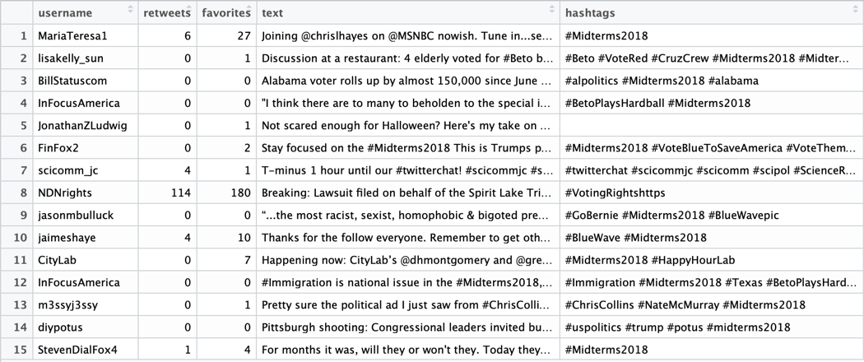

Figure 3.1

After collecting my data from Twitter, I then gathered data from the Botometer API using python. As mentioned before, Botometer calculates a CAP score based on up to 1,000 pieces of metadata that fall into six major categories: user, content, friend, network, sentiment and temporal (Varol et al. 2017). Using a self-created python function, I fed through the usernames from my Twitter data and in turn produced a CSV file with Botometer scores by username.[3] A sample of the resulting CSV can be seen in Figure 3.2. Some tweets were dropped due to Botometer being unable to assign them a score due to privacy restrictions. My final dataset, including Botometer scores, had 6,490 tweets. I then merged my two datasets, by username, from Twitter and Botometer, to create a final dataset that contained all relevant data. The final dataset was cleaned to include relevant variables, such as text, “universal” (the CAP score for each user), favorites, retweets and hashtags, remove common English words that create noise for analysis (i.e. stop words), remove special characters such as URLs and mentions, and remove duplicate usernames in the sample to prevent users from being double counted.

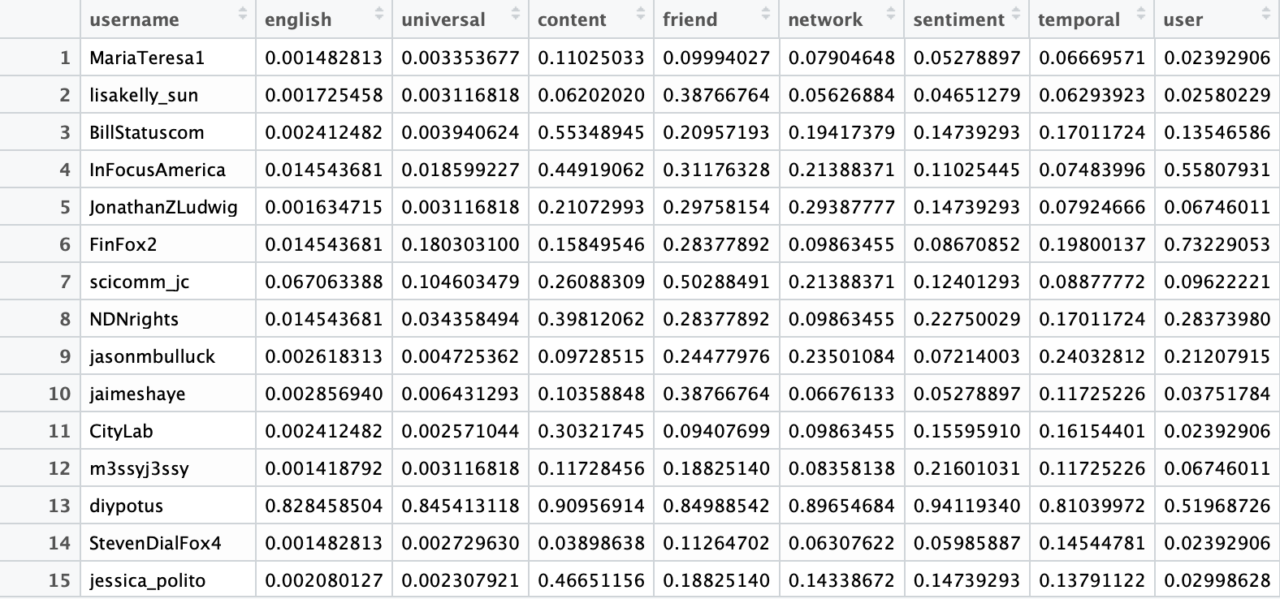 Figure 3.2

**IV. Methodology**

Next, a threshold for whether a user was a bot or a human was established. This was done through precursory data exploration. First, the mean CAP score of the sample is about 0.05, indicating most of the sample is human. The distribution of CAP scores is shown in Figure 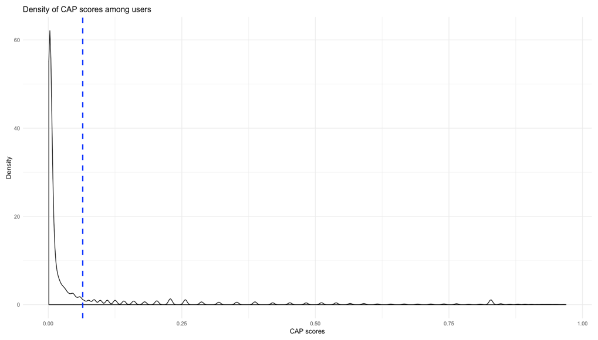4.1.

Figure 4.1

Botometer reports its predictive accuracy in brackets as follows: above 90% accuracy for the accounts in the (0.0, 0.4) range, 60% to 80% accuracy for accounts in the (0.4, 0.8) range, and above 70% accuracy for scores in the (0.8, 1.0) range (Varol 2017). Initially, the threshold for a bot was set at 0.8, maximizing the predictive accuracy of the CAP scores. However, this led to an extremely small sample (90 users), and after removing stop words, very few words were left (less than 50 words). Thus, I expanded the threshold for a bot to begin at 0.6 to increase my sample (181 users with 2,157 significant words), while maintaining a threshold that is more likely to predict a bot than predict a human. Therefore, I have 181 bots and 6,309 humans in my sample. While 0.6 may seem to be too low of a probability to predict a bot, researchers note that the CAP scores are an extremely conservative estimate, meaning perhaps it is higher in reality than it appears. Although this is an imperfect measure, it was necessary given the constraints of my data.

After a distinction between humans and bots was created, the resulting text data were compared for the two groups. The text data were analyzed first in an exploratory fashion, through comparing word frequencies, and then were analyzed through (1) sentiment analysis, using the “BING”, “NRC” and “AFINN” dictionaries and (2) topic modeling.

**V. Results**

I now address the research question discussed in the introduction by exploring differences between bots and humans in rhetoric, sentiment, and topic.

**Rhetoric**

A comparison of wordclouds of bots and humans (Figures 5.1 and 5.2 respectively) highlights distinct differences in the rhetoric of bots and of humans. Bots frequently mentioned specific states, such as Pennsylvania, Texas, and Florida. Notably, Pennsylvania and Florida are swing states, and in 2018, Texas had a highly contentious Senate race, Beto (D) versus Cruz (R), in which the winner was decided within a two percentage point margin (“Texas Senate Election Results”). Humans, on the other hand, did not frequently mention contentious states. Rather, humans mentioned “state”, “now” and “bluewave” frequently. Humans mentioned many more partisan terms, such as “bluewave”, “blue”, “votered”, “voteblue” and “democrats”, than the bots. Unsurprisingly, the most frequent words for both bots and humans were about elections in general (e.g., “election”, “vote”, “trump” and “house”).



Figure 5.1



Figure 5.2

Further exploration revealed (see Figure 5.3) that there was considerable overlap between the top ten most frequent words of bots and humans. The unique top ten frequent words used by bots were “texas”, “voters”, “issues”, “house”, “fighting”, and “video”. The unique top ten frequent words used by humans were “will”, “voting”, “state”, “week” and “via”. For the words that were frequent for both bots and humans, “elections” and “election” were much more common in bots than humans, while “vote” was much more common in humans than bots. “Trump” was more frequent in humans than bots.



Figure 5.3

**Sentiment Analysis**

The sentiment analysis shows that there is not a statistically significant difference between bots and humans’ sentiment in the AFINN and BING dictionary. Both bots and humans had positive averages close to zero, indicating they are somewhat neutral, or balanced in their use of positive and negative words, with a slight preference for positive words.

First, consider the analysis done using the AFINN dictionary (Figure 5.4). The AFINN dictionary gives each word a score, between -5 (extremely negative word) to 5 (extremely positive word). Bots have more positive words per user than negative words per user.[4] Bots have the most words per user in AFINN sentiment scores 1 and 2. There are very few, if any, words at either extreme of the AFINN dictionary (-5 or 5). The same pattern is seen in humans. I conducted a two-tailed t-test to further compare the sentiment of bots versus humans and find a p-value of 0.93, which is far above the 0.05 threshold needed for statistical significance.[5] Because the null hypothesis cannot be rejected, it seems that there is no difference between bots and humans in terms of their sentiment.

A similar analysis can be conducted for the BING dictionary (Figure 5.5). The BING dictionary is more simplified than the AFINN dictionary, assigning each word a binary sentiment, positive or negative. Once again, we see that bots and humans are more positive than negative per user. However, A two-tailed t-test on the BING dictionary data once again showing that humans and bots do not differ in sentiment, p = 0.94.[6]

Finally, using the NRC dictionary, a more nuanced comparison of sentiment can be seen. Bots used “trust” most frequently of the specified emotions (anger, anticipation, disgust, fear, joy, sadness, surprise and trust) provided by the NRC dictionary. Humans also used “trust” most frequently of the specified emotions, and anticipation the second most frequently.



Figure 5.4

Figure 5.5

Figure 5.6

**Topic Models**

Based on perplexity scores, a topic model with k = 2 is the best fit for the data.[7] For bots, topic two appears to be more geared towards the contentious elections, including words such as “Wallace”, “republican”, “texas”, “pennslyvania” and “fight”, while topic one is more generic election terms, such as “ballot”, “poll”, “official” and “american” (Figure 5.7). Humans exhibit less distinctions between topic models, with much overlap between words associated with both political parties, republicans and democrats, in each model (Figure 5.8). Similar trends are seen in beta distributions. The beta value represents the probability of a word being generated in a specific topic. For bots, on average, there was a larger spread between betas than for humans, further indicating bots had a stronger distinction between topics than the humans.[8]

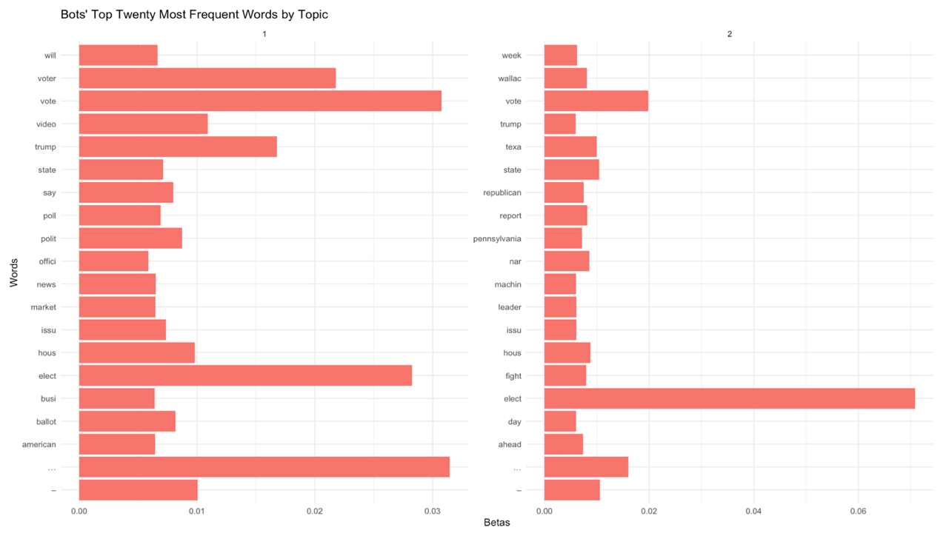

Figure 5.7



Figure 5.8

**VI. Discussion**

There are distinct differences between bots and humans in terms of rhetoric, few differences in topic and no differences in sentiment. These findings suggest that the bot “authors” are very sophisticated in creating bots that mimic humans in sentiment and topic, while at the same time subtly manipulating online social discourse through rhetoric. Rhetoric differences such as bots rarely mention democrats, but mention republicans; bots mention contentious elections more than humans, and bots mention Obama more than democrats, may indicate bots are manipulating conversation online. This is an area ripe for future research. It may be interesting to explore potential differences in bots and humans’ expressed ideology (through word choice), using supervised wordscore models and unsupervised wordfish models. Perhaps, there are differences in ideology between bots and humans.[9] If there were significant differences in ideology, particularly such that strong support is shown for one party, between bots and humans, that might be a strong indication for a disinformation campaign for that party.

Automated bot campaigns and the spread of disinformation on social media is an important topic and will continue to be an important topic in the coming years. Bots will continue to evolve and become more sophisticated, making it particularly important that there be continuing research on detection and mitigation of automated accounts. The more aware the public is regarding automated bot accounts and their impact on the online conversation, the more unbiased their decisions can be, especially around decisions as important as the next leader of their country. Thus, continued research on the topic is necessary to reduce influence of disinformation campaigns.

**Works Cited**

Allcott, Hunt, and Matthew Gentzkow. “Social Media and Fake News in the 2016 Election.” *Journal of Economic Perspectives*, vol. 31, no. 2, 2017, pp. 211–236., doi:10.3386/w23089.

Ausubel, Jacob. “Social Media and the 2018 Midterms: An Analysis of House Candidates' Twitter Posts.” *College Undergraduate Research Electronic Journal*, 26 Mar. 2019.

Badawy, Adam, et al. “Analyzing the Digital Traces of Political Manipulation: The 2016 Russian Interference Twitter Campaign.” *2018 IEEE/ACM International Conference on Advances in Social Networks Analysis and Mining (ASONAM)*, 2018, doi:10.1109/asonam.2018.8508646.

Board, Editorial. “Opinion | Russia Has Turned Its Interfering Attentions to Africa.” *The Washington Post*, WP Company, 3 Nov. 2019, www.washingtonpost.com/opinions/russia-has-turned-its-interfering-attentions-to-africa/2019/11/03/4a668d12-fb55-11e9-8190-6be4deb56e01_story.html.

Bradshaw , Samantha, and Philip N Howard. “2019 Global Inventory of Organized Social Media Manipulation.” *Computational Propaganda Research Project*, 2019, comprop.oii.ox.ac.uk/wp-content/uploads/sites/93/2019/09/CyberTroop-Report19.pdf.

Ferrara, Emilio, et al. “The Rise of Social Bots.” *Communications of the ACM*, vol. 59, no. 7, 2016, pp. 96–104., doi:10.1145/2818717.

Gingerich, Jon. “The Cost of Fake News: $78 Billion.” *O'Dwyers PR*, 26 Nov. 2019, www.odwyerpr.com/story/public/13448/2019-11-26/cost-fake-news-78-billion.html.

Luceri, Luca, et al. “Red Bots Do It Better:Comparative Analysis of Social Bot Partisan Behavior.” *Companion Proceedings of The 2019 World Wide Web Conference on - WWW '19*, May 2019, doi:10.1145/3308560.3316735.

Masters, Jonathan. “Russia, Trump, and the 2016 U.S. Election.” *Council on Foreign Relations*, Council on Foreign Relations, 26 Feb. 2018, www.cfr.org/backgrounder/russia-trump-and-2016-us-election#chapter-title-0-2.

Ozer, Mert. “Measuring the Impact of Bot Accounts on Political Network Polarization.” *Arizona State University*, 2019.

Richards, E. I. Velazquez, et al. “BoostNet: Bootstrapping Detection of Socialbots, and a Case Study from Guatemala.” *Springer Proceedings in Mathematics & Statistics Selected Contributions on Statistics and Data Science in Latin America*, Jan. 2019, pp. 145–154., doi:10.1007/978-3-030-31551-1_11.

Shao, Chengcheng. “The Spread of Fake News by Social Bots.” 24 July 2017, pp. 69–95.

“Small Share of U.S. Adults Produce Majority of Political Tweets.” *Pew Research Center for the People and the Press*, 13 Nov. 2019, www.people-press.org/2019/10/23/national-politics-on-twitter-small-share-of-u-s-adults-produce-majority-of-tweets/.

Stanley-Becker, Isaac, and Tony Romm. “Facebook Takedowns Show New Russian Activity Targeted Biden, Praised Trump.” *The Washington Post*, WP Company, 22 Oct. 2019, www.washingtonpost.com/technology/2019/10/21/facebook-fine-tunes-disinformation-defenses-but-leaves-controversial-political-ad-rules-intact/.

“Texas Senate Election Results: Beto O'Rourke vs. Ted Cruz.” *The New York Times*, The New York Times, 28 Jan. 2019, www.nytimes.com/elections/results/texas-senate.

“Threat to U.S. Elections in 2020 Is Not Limited to Russia.” *Associated Press*, Tampa Bay Times, 30 Oct. 2019, www.tampabay.com/news/nation-world/2019/10/30/threat-to-us-elections-in-2020-is-not-limited-to-russia/.

Varol, Onur. “Online Human-Bot Interactions: Detection, Estimation, and Characterization.” *International Conference for the Web and Social Media*, 27 Mar. 2017.

Wirth, Kurt, et al. “Bots By Topic.” *Proceedings of the 10th International Conference on Social Media and Society*, July 2019, doi:10.1145/3328529.3328547.

**Appendix A: Botometer Explanation**

Botometer is a API created by the Indiana University that calculates the probability a Twitter account is a bot by extracting up to 1,000 pieces of information about each account. It uses six main categories of information when calculating its probability score. These categories include:

* User: Contains user-specific metadata such as the user name, language, location, account created date etc., Generally, bots do not contain such information. And if they do, it will be something gibberish.
* Content: Focuses on the actual content of the tweet. The researchers extracts language features by applying the Part-of-Speech (POS) tagging technique, which identifies different types of natural language components, or POS tags. Tweets are therefore analyzed to study how POS tags are distributed.
* Friend: Considers four types of links retweeting, mentioning, being retweeted, and being mentioned. For each group separately, we extract features about language use, local time, popularity, etc. Due to Twitter’s API limits, researchers do not use follower/followee information beyond these aggregate statistics.
* Network: Includes information on the retweets, mentions, and hashtags that a user tweeted in the past and creates co-occurrence networks for each of these. All networks are weighted according to the frequency of interactions or co- occurrences. For each network, we compute a set of features, including in- and out-strength (weighted degree) distributions, density, and clustering.
* Sentiment: Analyzes the sentiment of the tweets by the specified user through sentiment extraction techniques such as arousal, valence and dominance scores (Warriner, Kuperman, and Brysbaert 2013), happiness score (Kloumann et al. 2012), polarization and strength (Wilson, Wiebe, and Hoffmann 2005), and emoticon score (Agarwal et al. 2011).
* Temporal: analyzes the average tweet rate of an user and timing patterns of tweeting and retweeting.

Researchers used training data from two sources, (1) a publicly available dataset of known Twitter bots and (2) a manually annotated collection of active Twitter users that include both humans and bots of varying sophistication. The data is then broken down by the six variables and used in a random forest algorithm to determine the Complete Automation Probability (CAP) score, which indicates the probability that the account is a bot.

**Appendix B: Python Twitter Scraping Code**

GetOldTweets3 --querysearch "Midterms 2018" --since 2018-10-29 --until 2018-10-31 --lang en --output macstwitterdata.csv

**Appendix C: Python Botometer Data Code**

import botometer

from collections import OrderedDict

import csv

rapidapi_key[10] = "XXX"

twitter_app_auth = {

    'consumer_key': 'XXX',

    'consumer_secret': 'XXX',

    'access_token': 'XXX',

    'access_token_secret': 'XXX',

}

bom = botometer.Botometer(wait_on_ratelimit=True,

                          rapidapi_key=rapidapi_key,

                          **twitter_app_auth)

import pandas as pd

#load screenames

testdata = pd.read_csv("Downloads/macstwitterdata.csv", encoding="ISO-8859-1")

accounts = list(testdata.username)

accounts2 = list(OrderedDict.fromkeys(accounts))

#create function that parces the correct subset of the JSON

def obj_creator(d):

    try:

        result = bom.check_account(d)

    except:

        return {}, {}, {}

    return result["user"],result["cap"],result["categories"]

#print 50 of the accounts

with open('all_results.csv', mode='w') as f:

    writer = csv.writer(f, delimiter=',')

    writer.writerow(["id_str","screen_name","english","universal","content","friend","network","sentiment",

                     "temporal","user"])

    for i in range(len(accounts2)):

        user, cap, cats = obj_creator(accounts2[i])

        if len(user) > 0:

            writer.writerow([user["id_str"],user["screen_name"],cap["english"],cap["universal"],cats["content"],

                        cats["friend"],cats["network"],cats["sentiment"],cats["temporal"],cats["user"]])

**Appendix D: T-tests**

T-Test for AFINN dictionary



T-Test for BING dictionary

**Appendix E: Perplexity Score Analysis**

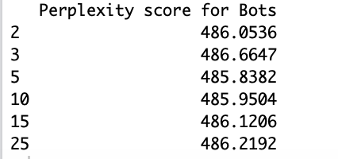

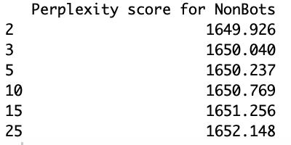

**Appendix F: Beta Scores for Topic Models**

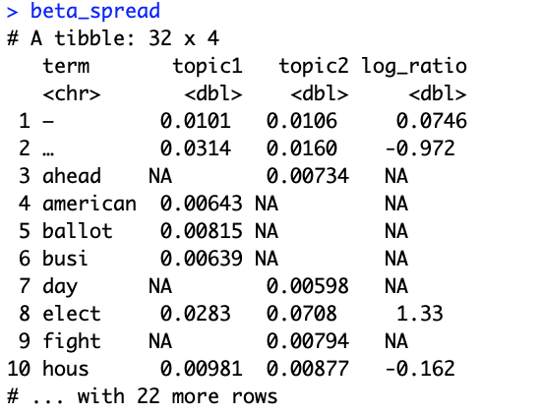Beta Scores for Bots

Beta Scores for Nonbots

**Appendix G: R code**

#libraries

library(tidyverse)

library(rtweet)

library(tidytext)

library(readr)

library(ggplot2)

set.seed(1234)

#load twitter data

twitter <- read.csv("~/Desktop/macstwitterdata.csv", header = TRUE)

twitter <- twitter %>% select("username", "retweets", "favorites", "text", "hashtags" )

rownames(twitter) <- c()

#load botometer data

botometer <- read.csv("~/Desktop/botometer_results.csv", header = TRUE)

botometer <- botometer %>%

rename(username = screen_name) %>% #to match twitter data

select(-id_str)

#merge

data <- merge(twitter, botometer, by = "username", header = TRUE)

#explore how many repeated users

duplicates <- length(data[!duplicated(data$username), ])

duplicates

#very very few, so will drop duplicates

#keep only unique users so don't accidentally double count

data <- data %>% distinct(username, .keep_all = TRUE)

#Explore data

#density of CAP scores plot

data %>%

ggplot(aes(x = english)) +

geom_density() +

geom_vline(aes(xintercept=mean(english)),

color="blue", linetype="dashed", size=1) +

labs(x = "CAP scores",

y = "Density",

title = "Density of CAP scores among users") +

theme_minimal()

#most common CAP scores

CAP_frequency <- data %>%

count(english, sort = TRUE)

#intial precursory look (Figure 4.1)

CAP_frequency %>%

ggplot(aes(x = english, y = n)) +

geom_bar(stat="identity",

color = "Blue",

show.legend = FALSE) +

labs(x = "CAP score (english)",

y = "Frequency of CAP score") +

theme_minimal()

#counts

CAP_lessthan<- CAP_frequency %>%

filter(english < .6)

sum(CAP_lessthan$n)

CAP_greaterthan<- CAP_frequency %>%

filter(english >= .6)

sum(CAP_greaterthan$n)

#graph (not included)

CAP_frequency %>%

mutate(bot = ifelse(english < .6, "nonbot", "bot")) %>%

ggplot(aes(x = bot, y = n, fill= factor(bot))) +

geom_bar(stat="identity",

show.legend = FALSE) +

#geom_text(aes(label=n), vjust=-0.3, size=3.5) +

labs(x = "User Type",

y = "Frequency",

title = "Frequency of Bots vs. Nonbots") +

#geom_text(aes(x=bot, y=n, label=n), size = 2) +

theme_minimal()

#way more probable to get human than a bot, say all acounts with prob > .6 a bot

#label account bot(1) or not bot (0)

data <- data %>%

mutate(bot =

ifelse(english < .6, 0 , 1))

#check

#data %>%

count(bot == 0)

#sum(CAP_lessthan$n)

#they are the same, yay!

#clean data for sentiment analysis

library(tm)

library(dplyr)

library(textclean)

#turn into a corpus, 1 for bots, 1 for humans

bot <- data %>%

filter(bot == 1)

bot_corp <- Corpus(VectorSource(bot$text))

nonbot <- data %>%

filter(bot == 0)

nobot_corp <- Corpus(VectorSource(nonbot$text))

#check

#writeLines(as.character(bot_corp[1]))

#remove uppercase

tidy_bot <- tm_map(bot_corp, tolower)

#REMOVE URLS and @ mentions

tidy_bot <- gsub("@([a-zA-Z0-9]|[_])*", "", tidy_bot)

tidy_bot <- Corpus(VectorSource(tidy_bot))

tidy_bot <- tidy_bot[1]

tidy_bot <- replace_url(tidy_bot)

tidy_bot <- Corpus(VectorSource(tidy_bot))

#check using a tweet with @ and url

#writeLines(as.character(tidy_bot[1]))

#tidy bots

#remove punctuation

tidy_bot <- tm_map(tidy_bot, removePunctuation) #back to one doc per tweet

#remove special characters

for (j in seq(tidy_bot)) {

tidy_bot[[j]] <- gsub("/", " ", tidy_bot[[j]])

tidy_bot[[j]] <- gsub("’", " ", tidy_bot[[j]])

tidy_bot[[j]] <- gsub("—", " ", tidy_bot[[j]])

tidy_bot[[j]] <- gsub("\\|", " ", tidy_bot[[j]])

tidy_bot[[j]] <- gsub("@", " ", tidy_bot[[j]])

tidy_bot[[j]] <- gsub("\u2028", " ", tidy_bot[[j]])

}

tidy_bot <- tm_map(tidy_bot, PlainTextDocument)

#remove stopwords

tidy_bot<- tm_map(tidy_bot,

removeWords,

stopwords("english"))

#remove numbers

tidy_bot <- tm_map(tidy_bot, removeNumbers)

#get rid of white space

tidy_bot <- tm_map(tidy_bot, stripWhitespace)

tidy_bot <- tm_map(tidy_bot, PlainTextDocument)

#check what we are working with

#writeLines(as.character(tidy_bot[1]))

#tidy nonbots

#remove uppercase

tidy_nonbot <- tm_map(nobot_corp, tolower)

#REMOVE @ mentions

tidy_nonbot <- gsub("@([a-zA-Z0-9]|[_])*", "", tidy_nonbot)

tidy_nonbot <- Corpus(VectorSource(tidy_nonbot))

tidy_nonbot <- replace_url(tidy_nonbot)

tidy_nonbot <- Corpus(VectorSource(tidy_nonbot))

#remove punctuation

tidy_nonbot <- tm_map(tidy_nonbot, removePunctuation)

#remove special characters

for (j in seq(tidy_nonbot)) {

tidy_nonbot[[j]] <- gsub("/", " ", tidy_nonbot[[j]])

tidy_nonbot[[j]] <- gsub("’", " ", tidy_nonbot[[j]])

tidy_nonbot[[j]] <- gsub("—", " ", tidy_nonbot[[j]])

tidy_nonbot[[j]] <- gsub("\\|", " ", tidy_nonbot[[j]])

tidy_nonbot[[j]] <- gsub("@", " ", tidy_nonbot[[j]])

tidy_nonbot[[j]] <- gsub("\u2028", " ", tidy_nonbot[[j]])

}

tidy_nonbot <- tm_map(tidy_nonbot, PlainTextDocument)

#remove stopwords

tidy_nonbot<- tm_map(tidy_nonbot,

removeWords,

stopwords("english"))

#remove numbers

tidy_nonbot <- tm_map(tidy_nonbot, removeNumbers)

#get rid of white space

tidy_nonbot <- tm_map(tidy_nonbot, stripWhitespace)

tidy_nonbot <- tm_map(tidy_nonbot, PlainTextDocument)

#check what we are working with

#writeLines(as.character(tidy_nonbot[1]))

library("wordcloud")

library("RColorBrewer")

library(textclean)

#wordclouds Figure 5.1 and 5.2

set.seed(123)

wordcloud(as.character(tidy_bot[1]),

max.words = 150,

scale=c(3,.2),

random.order=FALSE,

colors = brewer.pal(11, "BrBG"),

random.color = TRUE)

#after viewing precursory wordcloud, need to take out some words such as "midterms 2018"(selected on that so no it's most common), midterm, 2018

for (j in seq(tidy_bot)) {

tidy_bot[[j]] <- gsub("midterm", " ", tidy_bot[[j]])

tidy_bot[[j]] <- gsub("midterms", " ", tidy_bot[[j]])

}

#wordcloud 2.0

set.seed(123)

wordcloud(as.character(tidy_bot[1]),

max.words = 200,

scale=c(4, .5),

random.order=FALSE,

colors = brewer.pal(11, "BrBG"),

random.color = TRUE)

#nonbots

#remove same words from nonbot

for (j in seq(tidy_nonbot)) {

tidy_nonbot[[j]] <- gsub("midterm", " ", tidy_nonbot[[j]])

tidy_nonbot[[j]] <- gsub("midterms", " ", tidy_nonbot[[j]])

}

set.seed(123)

wordcloud(as.character(tidy_nonbot[1]),

max.words = 200,

random.order=FALSE,

scale=c(4, .3),

colors = brewer.pal(11, "BrBG"),

random.color = TRUE)

#figure 5.3

library(tidytext)

library(ggplot2)

library(tm)

library(topicmodels)

tokens_bots <- data_frame(text = as.character(tidy_bot[1])) %>% unnest_tokens(word, text)

tokens_nonbots <- data_frame(text = as.character(tidy_nonbot[1])) %>% unnest_tokens(word, text)

#get into 1 data frame to compare

tokens_bots <- tokens_bots %>%

mutate(bot = 1)

tokens_nonbots <- tokens_nonbots %>%

mutate(bot = 0)

tokens <- rbind(tokens_bots,tokens_nonbots)

counts <- tokens %>%

count(word, bot, sort = TRUE) %>%

mutate(words_per_user = ifelse(bot == 0,

(n/sum(CAP_lessthan$n)),

(n/sum(CAP_greaterthan$n)))) #standardize by words per user

top_n_nonbot <- counts %>%

filter(word != "s") %>%

filter(bot == 0) %>%

select(word, bot, words_per_user) %>%

top_n(10)

top_n_bots <- counts %>%

filter(word != "s") %>%

filter(bot == 1) %>%

select(word, bot, words_per_user) %>%

top_n(10)

counts <- rbind(top_n_bots, top_n_nonbot)

counts %>%

mutate(bot = ifelse(bot == 0 , "Nonbot", "Bot")) %>%

ggplot(aes(x = word, y = words_per_user, fill = factor(bot))) +

facet_wrap(~ bot, scales = "free", ncol = 2) +

geom_col(show.legend = TRUE) +

coord_flip() +

labs(x = "Word",

y = "Frequency of Word (per user)",

title = "Comparison between Bots and Nonbots Top Ten Most Frequent Words",

fill = "User Type") +

theme_minimal()

#sentiment analysis

library(tidytext)

afinn_bots <- tokens_bots %>%

inner_join(get_sentiments("afinn"))

afinn_nonbots <- tokens_nonbots %>%

inner_join(get_sentiments("afinn"))

#top words for bots afinn

tokens_bots %>%

count(word, sort = TRUE) %>%

inner_join(get_sentiments("afinn"))

#so 6/10 of the top ten words are negative

#top words for nonbots afinn

tokens_nonbots %>%

count(word, sort = TRUE) %>%

inner_join(get_sentiments("afinn"))

#all but 1 of the top ten words are positive

tokens %>%

count(word, bot, sort = TRUE) %>%

mutate(words_per_user = ifelse(bot == 0,

(n/sum(CAP_lessthan$n)),

(n/sum(CAP_greaterthan$n)))) %>% #standardize per user

mutate(bot = ifelse(bot == 0 , "Nonbot", "Bot")) %>%

inner_join(get_sentiments("afinn")) %>%

ggplot(aes(x= bot, y = words_per_user, fill = factor(bot))) +

geom_col(show.legend = TRUE) +

facet_wrap( ~ score) +

coord_flip() +

labs(title = "Sentiment across Bots and Nonbots",

subtitle = "Using AFINN Dictionary",

x = "Type of user",

y = "Frequency of words per user",

fill = "User Type") +

theme(axis.text.x = element_text(angle = 45, hjust = 1),

axis.text.y = element_blank(),

axis.ticks.y = element_blank())

#afinn mean analysis

mean_afinn_bots <- mean(afinn_bots$score)

mean_afinn_bots

mean_afinn_nonbots <- mean(afinn_nonbots$score)

mean_afinn_nonbots

#nrc

nrc_bots <- tokens_bots %>%

inner_join(get_sentiments("nrc"))

nrc_nonbots <- tokens_nonbots %>%

inner_join(get_sentiments("nrc"))

tokens %>%

count(word, bot, sort = TRUE) %>%

mutate(words_per_user = ifelse(bot == 0,

(n/sum(CAP_lessthan$n)),

(n/sum(CAP_greaterthan$n)))) %>% #standardize per user

mutate(bot = ifelse(bot == 0 , "Nonbot", "Bot")) %>%

inner_join(get_sentiments("nrc")) %>%

ggplot(aes(x= bot, y = words_per_user, fill = factor(bot))) +

geom_col(show.legend = TRUE) +

facet_wrap( ~ sentiment) +

coord_flip() +

labs(title = "Sentiment across Bots and Nonbots",

subtitle = "Using NRC Dictionary",

x = "Type of user",

y = "Frequency of words per user",

fill = "User Type") +

theme(axis.text.x = element_text(angle = 45, hjust = 1),

axis.text.y = element_blank(),

axis.ticks.y = element_blank())

#t tests (appendix d)

t.test(bing_nonbots$sentiment,bing_bots$sentiment)

t.test(afinn_bots$score, afinn_nonbots$score)

#stem

stem_bot <- Corpus(VectorSource(tidy_bot))

stem_bot <- tm_map(stem_bot,stemDocument)

stem_bot <- tm_map(stem_bot, PlainTextDocument)

stem_nonbot <- Corpus(VectorSource(tidy_nonbot))

stem_nonbot <- tm_map(stem_nonbot, stemDocument)

stem_nonbot <- tm_map(stem_nonbot, PlainTextDocument)

#dtm

dtm_bot <- DocumentTermMatrix(stem_bot[1])

dtm_nonbot <- DocumentTermMatrix(stem_nonbot[1])

#topic models

library(topicmodels)

bot_lda_2 <- LDA(dtm_bot, k = 2, control = list(seed = 1234))

bot_lda_3 <- LDA(dtm_bot, k = 3, control = list(seed = 1234))

bot_lda_5 <- LDA(dtm_bot, k = 5, control = list(seed = 1234))

bot_lda_10 <- LDA(dtm_bot, k = 10, control = list(seed = 1234))

bot_lda_25 <- LDA(dtm_bot, k = 25, control = list(seed = 1234))

bot_lda_15 <- LDA(dtm_bot, k = 15, control = list(seed = 1234))

#perplexity scores (appendix e)

perplexity(bot_lda_2)

perplexity(bot_lda_3)

perplexity(bot_lda_5)

perplexity(bot_lda_10)

perplexity(bot_lda_25)

perplexity(bot_lda_15)

#so 2 is best for bots

bot_lda_perplex_table <- matrix(c(perplexity(bot_lda_2),perplexity(bot_lda_3),perplexity(bot_lda_5),perplexity(bot_lda_10),

perplexity(bot_lda_15),perplexity(bot_lda_25)),

ncol=1, nrow=6)

colnames(bot_lda_perplex_table) <- c("Perplexity score for Bots")

rownames(bot_lda_perplex_table) <- c(2,3,5,10,15,25)

bot_lda_perplex_table <- as.table(bot_lda_perplex_table)

bot_lda_perplex_table

nonbot_lda_2 <- LDA(dtm_nonbot, k = 2, control = list(seed = 1234))

nonbot_lda_3 <- LDA(dtm_nonbot, k = 3, control = list(seed = 1234))

nonbot_lda_5 <- LDA(dtm_nonbot, k = 5, control = list(seed = 1234))

nonbot_lda_10 <- LDA(dtm_nonbot, k = 10, control = list(seed = 1234))

nonbot_lda_25 <- LDA(dtm_nonbot, k = 25, control = list(seed = 1234))

nonbot_lda_15 <- LDA(dtm_nonbot, k = 15, control = list(seed = 1234))

perplexity(nonbot_lda_2)

perplexity(nonbot_lda_3)

perplexity(nonbot_lda_5)

perplexity(nonbot_lda_10)

perplexity(nonbot_lda_25)

nonbot_lda_perplex_table <- matrix(c(perplexity(nonbot_lda_2),perplexity(nonbot_lda_3),perplexity(nonbot_lda_5),perplexity(nonbot_lda_10),

perplexity(nonbot_lda_15),perplexity(nonbot_lda_25)),

ncol=1, nrow=6)

colnames(nonbot_lda_perplex_table) <- c("Perplexity score for NonBots")

rownames(nonbot_lda_perplex_table) <- c(2,3,5,10,15,25)

nonbot_lda_perplex_table <- as.table(nonbot_lda_perplex_table)

nonbot_lda_perplex_table

#topic models (Figure 5.7 and 5.8)

bot_lda <- LDA(dtm_bot, k = 2, control = list(seed = 1234))

library(tidytext)

tidy_bot_lda <- tidy(bot_lda, matrix = "beta")

library(ggplot2)

library(dplyr)

library(tidyr)

bot_lda_ten_top_terms <- tidy_bot_lda %>%

group_by(topic) %>%

top_n(20, beta) %>%

ungroup() %>%

arrange(topic, -beta)

bot_lda_ten_top_terms %>%

ggplot(aes(term, beta, fill = topic)) +

geom_col(show.legend = TRUE, fill = "#F8766D") +

facet_wrap(~ topic, scales = "free") +

labs(title= "Bots' Top Twenty Most Frequent Words by Topic",

y="Betas", x = "Words",

fill = "Topic Model") +

coord_flip() +

theme_minimal()

#beta= topic per word probability

beta_spread <- bot_lda_ten_top_terms %>%

mutate(topic = paste0("topic", topic)) %>%

spread(topic, beta) %>%

filter(topic1 > .001 | topic2 > .001) %>%

mutate(log_ratio = log2(topic2 / topic1))

beta_spread

#create topic model

nonbot_lda <- LDA(dtm_nonbot, k = 2, control = list(seed = 1234))

tidy_nonbot_lda <- tidy(nonbot_lda, matrix = "beta")

nonbot_lda_ten_top_terms <- tidy_nonbot_lda %>%

filter(term != " ... ") %>%

group_by(topic) %>%

top_n(20, beta) %>%

ungroup() %>%

arrange(topic, -beta)

nonbot_lda_ten_top_terms %>%

ggplot(aes(term, beta)) +

geom_col(show.legend = TRUE, fill = "#00BFC4") +

facet_wrap(~ topic, scales = "free") +

labs(title= "Nonbots' Top Twenty Most Frequent Words by Topic",

y="Betas", x = "Words") +

coord_flip() + theme_minimal()

#try this out... not sure what it means read about

beta_spread_nonbots <- nonbot_lda_ten_top_terms %>%

mutate(topic = paste0("topic", topic)) %>%

spread(topic, beta) %>%

filter(topic1 > .001 | topic2 > .001) %>%

mutate(log_ratio = log2(topic2 / topic1))

beta_spread_nonbots

1. For more information on Botometer and its methodology, see Appendix A.
2. See Appendix B for the corresponding code.
3. See Appendix C for the corresponding code.
4. Words per user is a calculated by dividing the frequency of a word (n)/ by the total number of bot/nonbot users in an attempt to make results more comparable between bots and nonbots, given that there is such a large difference in number of bots (181) and number of nonhumans (6,309) in my sample. Bots’ words per user are not directly comparable to nonbots’ words per user because it does not standardize for number of words. Naturally, nonbots will have many more words than nonbots given there are significantly more nonbot users.
5. See appendix D for full t-test results.
6. See appendix D for full t-test results.
7. Perplexity score analysis can be found in Appendix E.
8. See Appendix F for full beta results.
9. I attempted to conduct such analyses with my data; however, it took too long to run on my computer to return a result.
10. Input your own personalized rapid API keys and twitter API keys.